โปรโมชั่น เดือนพฤษภาคม 2563

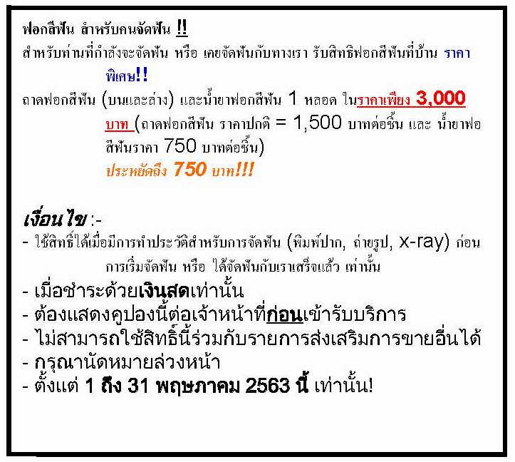

Mr. /Mrs./ Miss : .........................................................
You have known our website via O www.google.com O …………………..

Please show the coupon to our staff upon registration.
We reserve the rights of not giving the special privilege if the coupon is not being shown before the treatment starts.

